# **Checklist methods for GALENOS meta-analyses – lsr3**

Produce prediction intervals and show them in forest plot

SS: Prediction intervals were not presented given the small number of studies (as suggested before).

Report τ (estimate of heterogeneity)

SS: Tau-squared is reported along with I-squared in the forest plots and summary of the evidence tables.

Use Hartung-Knapp adjustment for confidence intervals (unless < 5 studies)

SS: Hartung-Knapp was used even if the number of studies <5 (as suggested before). Due to small CIs in some occasions, the adhoc.hakn.ci=”se’ was used throughout (“*use variance correction if HK standard error is smaller than standard error from classic random effects meta-analysis (Knapp and Hartung, 2003*”)

For small sample sizes & rare outcomes: Mantel-Haenszel adjustment

SS: Fixed-effects and MH method was used for outcomes deemed as rare events, i.e., mortality and serious adverse events (many 0 event cells). It would be nice if you could check the other outcomes, in case you believe they could be considered rare outcomes.

Contour-enhanced funnel plots (if ≥ 10 studies)

SS: Funel plots were not drawn as <5 studies available.

Sensitivity analysis restricting to only low risk of bias studies

SS: This sensitivity analysis was not conducted due to small number of studies AND no study with low risk of bias. (P.S. 4 studies essentially available for the primary outcome, no subgroup or sensitivity analysis was conducted).

Additional comments

Crossover trials

* Dichotomous outcomes. Crossover studies did not report the first phase. I analysed them according to Elbourne et al. 2002 (<https://academic.oup.com/ije/article/31/1/140/655940?login=false>), and specifically (assuming 0 correlation as it may be appropriate probably for adverse events):

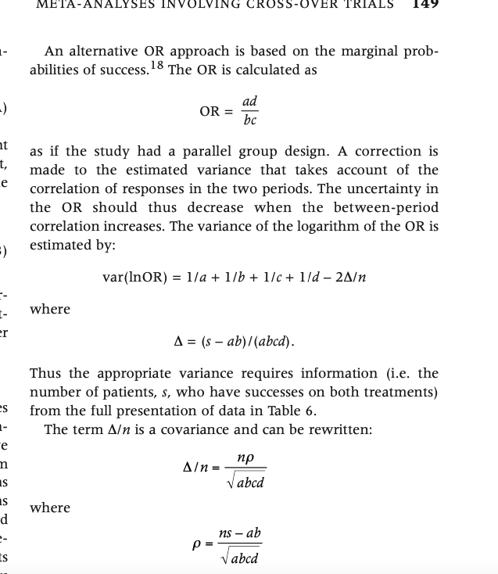

* One crossover study (Tsukada et al., 2023) reported data for a continuous outcome, i.e., QTc interval in msec taking into consideration the crossover periods, i.e., mixed-effect models and used the TE and seTE as reported from that study. However, the study reported multiple time points within a day (not equidistant). Therefore, I calculated the AUC and then divided it by 24 hours in order to have daily estimate. For this reason, I used a formula that I found in the internet and computed the AUC for the point estimate, as well as the lower and upper boundaries of the 95% CI (subsequently I calculated the SE from them). See below (reported also in data/clean_data.R)

#Function for calculating AUC

AUC <- function (conc, time)

{

auc <- 0

for (i in 2:(length(time))) {

auc <- auc + (time[i] - time[i - 1]) * (conc[i] + conc[i - 1])/2

}

auc

}

#Calculate the mean AUC of QTc interval, and the divide by 24 hours in order to have the overall daily assessment

qtc_auc_mean<-AUC(data_qtc$TE, data_qtc$timepoint)/24

#Calculate the lower boundary of the AUC of QTc interval, and the divide by 24 hours in order to have the overall daily assessment

qtc_aub_lb<-AUC(data_qtc$lb, data_qtc$timepoint)/24

#Calculate the upper boundary of the AUC of QTc interval, and the divide by 24 hours in order to have the overall daily assessment

qtc_aub_ub<-AUC(data_qtc$ub, data_qtc$timepoint)/24

qtc_aub_se<-(qtc_aub_ub-qtc_aub_lb)/3.92

* Another crossover study (Hopkins et al 2021) had three phases for 2 doses of ulotaront and one for placebo. I did not know how to analyse this, and thus, I excluded the lower dose of ulotaront. Do you know any other better way for this?